Dataset: https://www.kaggle.com/datasets/datasnaek/chess

Motivation and Goals:
For this project, we aim to develop an interactive dashboard that provides insightful visualizations of a chess dataset. This dataset contains a variety of columns that allow us to explore different aspects of chess gameplay and create additional features for analysis. Our target audience includes chess players of all skill levels, from beginners to experienced players. We want to ensure that our dashboard is accessible and easy to understand, even for those with minimal experience in data visualization. The dashboard should provide useful insights that can help players learn more about chess trends, openings, and game outcomes. Through our visualizations, we aim to address the following questions: What are the most common openings played? Which openings give White or Black the best chance of winning? What are the most common ways games end (e.g., checkmate, resignation, draw)? What are the most common responses to specific moves? How do different time controls affect game length and outcomes? To assess the effectiveness of our dashboard, we will consider the following objective test: Measure how long users take to find answers to specific questions using the dashboard. Our goal is to make the dashboard intuitive, engaging, and informative for chess enthusiasts at any level.
Literature Review:
Current interactive interfaces for chess statistics employ lists of statistics grouped by categories like time controls, openings, etc., such as in Chess Monitor or Chess.com. These statistics are generally visualized through a bar separated into three colors – green, grey, and red – to indicate the percentage of wins, draws, and losses with respect to the chosen categories, as well as a count of games played under each category.
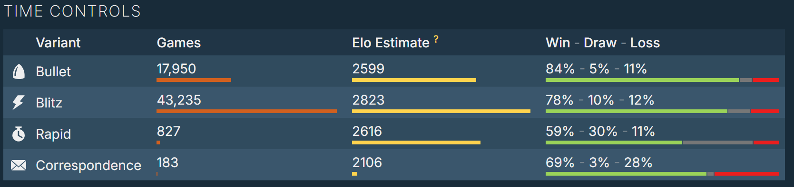

One observation is that the statistics in most chess analytics interfaces are calculated from the games of one player instead of many. While this is great for individualized evaluation of one’s skills and tendencies, it does not provide for an objective view of chess trends across chess players worldwide.
Some existing interactive chess interfaces (such as Chess.com and open-source tools like this Reddit project) incorporate similar techniques to our proposed visualizations. Our dashboard aims to offer a broader, more interactive approach. Some visualizations on existing interfaces:
- Top 3 best moves & replies per position.
- Opening response heatmaps showing the most frequent starting moves.
- Correlation maps between numerical game aspects (e.g., game length vs. rating).
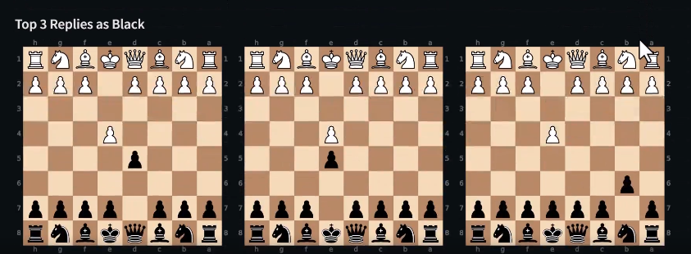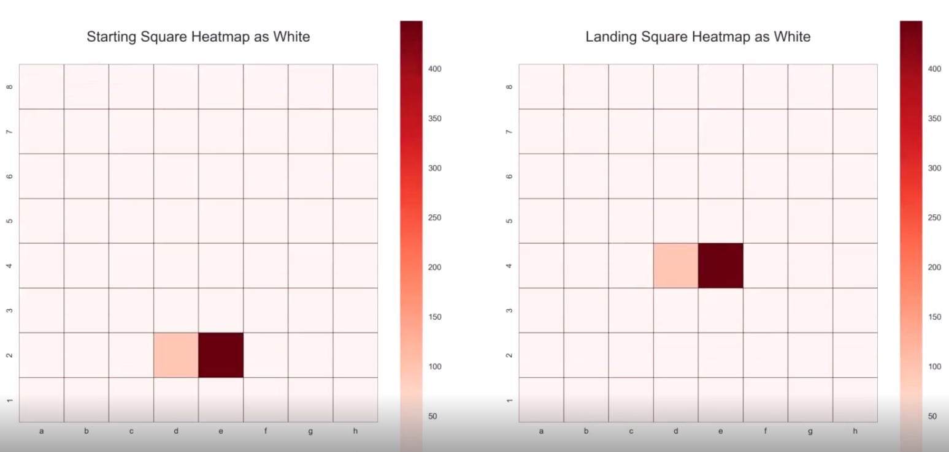

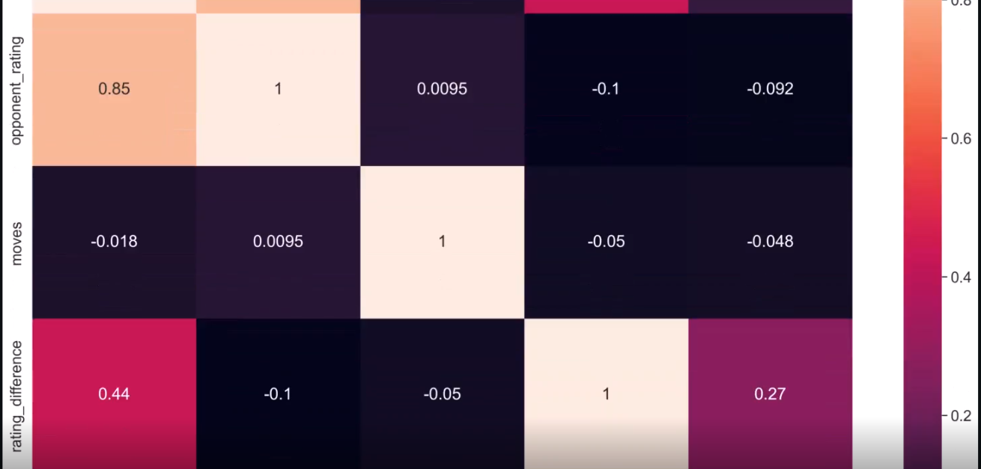

Packages / Implementation

The R packages we will most likely use may include ggplot2, plotly, ggiraph, and shiny. Plotly and ggiraph are tools specifically made for interactive visualizations in R, including features such as tooltips and side-by-side highlighting of data points across multiple graphs. Similarly, the shiny package is also built for interactive web apps for data visualization and UI; as we have seen in class, its many features include sliders, filtered tables, and more.

In our visualizations, we may display an interactive heatmap by using heatmaply to highlight move frequency across different squares, which can help identify common opening patterns. Additionally, Tree Diagrams can be used to visualize chess opening repertoires with the ggtree package, which structures move sequences into a hierarchical tree to help analyze decision paths in openings, different variation branches, and win percentages for each branch. However, a major challenge with deep game trees is that they can display too many variations/branches, making the visualization harder to interpret. Implementing pruning mechanisms—such as filtering by frequency—can help users focus on relevant decision points rather than being overloaded with less meaningful move sequences.
For move sequence analysis, ggraph can be used to create Network Graphs, which highlight how different moves connect within a game. This allows us to trace the most common transitions between different positions and understand game flow. Using ggraph, we can also animate move transitions to enhance clarity when exploring frequent responses to specific openings or mid-game strategies.
We can use tools like the igraph package in R to create network graphs as well, which let users define nodes, edges, customize layouts, and add interactive features like hovering over a node to see detailed move statistics or click on an edge to explore specific game outcomes.

igraph GitHub
igraph interface
igraph CRAN
Decision trees
The article "Unlocking the Tree of Analysis" discusses the importance of structured decision-making in chess through tree-based analysis. This approach models potential moves as branches, helping players systematically explore variations and anticipate counterplays.
- Branches & Variations; Each possible move creates a new branch, with sub-branches based on the opponent’s responses.
- Depth vs Breadth Tradeoff: Players must balance how many moves ahead (depth) vs. how many variations to consider (breadth). Depth allows foresight into future positions, while breadth ensures multiple possibilities are considered.
- Pruning: Not all move sequences are equally valuable. Eliminating unlikely or weak variations helps focus on promising decisions.
- Interactive filtering can make a display less overwhelming.
Graph Networks
The article "How to Analyze Chess Games Using Graph Networks" introduces the application of Graph Neural Networks (GNNs) to chess analysis. Unlike tree diagrams, graph representations model the chessboard as a network of connected moves, where:
- Chess positions are represented as graphs, with squares as nodes and legal moves as edges between the nodes.
- GNNs can process complex relationships between piece positions, move interactions, and spatial dependencies.
- This method can uncover hidden strategic patterns that are not obvious in traditional game analysis.
In Chapter 7: Networks of Interactive Data Visualization for the Web, Scott Murray discusses the use of network graphs to represent complex relationships in depth, such as move sequences and player interactions. This technique could be applied to visualize common opening variations and their outcomes, helping users understand the strategic implications of different moves and the responses players make to one another. Applying network-based approaches in our visualization could be beneficial for identifying common transition pathways between midgame and endgame positions, as well as detecting how certain move choices impact game outcomes across rating distributions.

Timeline Visualization
Visualizing Time-Oriented Data by Wolfgang Aigner et al. explores methods for representing temporal data, such as game length and move timing. Techniques like Gantt charts (Chapter 5) or timeline visualizations (Chapter 6) could help users analyze how different time controls affect game dynamics and outcomes.

Gantt charts are commonly used to represent schedules or timelines, but they can also be adapted to visualize chess games. Each move can be represented as a horizontal bar, with the length of the bar indicating the time taken for that move. This allows users to analyze how time is allocated throughout a game and identify patterns in how time control affects the game. For example, users could compare the time allocation of two players in a blitz game to see who managed their clock more effectively.

Timeline visualizations represent events along a linear time axis, making them ideal for analyzing move timing and game progression. Each move can be plotted as a point on the timeline, with additional annotations indicating key moments, such as captures or checkmates. They could help users analyze the pacing of a game, such as when critical moves were made or how long players spent on specific phases (e.g. opening, middlegame, endgame). This could provide insights into player behavior and decision-making under time pressure.

